Project Design Phase-II

Data Flow Diagram & User Stories
Date | 31 January 2025
Team ID | LTVIP2025TMID32756
Project Name | Pollen's Profiling: Automated Classification of Pollen Grains
Maximum Marks | 4 Marks

Data Flow Diagram (DFD)
Level 0 – DFD (Simplified Description)
Actors:
- User (Researcher/Scientist)
- System
- Image Classifier (AI Model)
- Database
Processes:
1. Upload Pollen Image
2. Process Image
3. Classify Pollen Type
4. Store/Display Results
Data Stores:
- Image Repository
- Classification Results DB
Flow:
- User uploads a pollen grain image.
- System receives image and processes it through the AI model.
- Classification results are stored in the database.
- Results are displayed to the user.

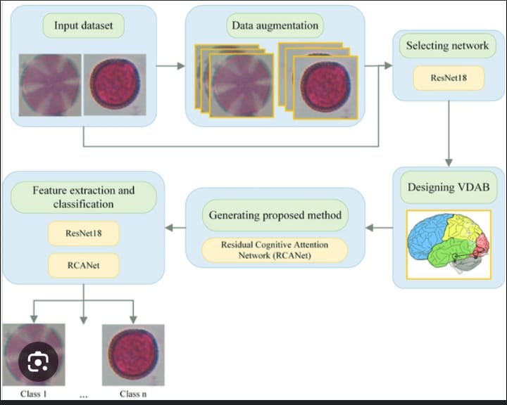

User Stories
User Type | Functional Requirement (Epic) | User Story Number | User Story / Task | Acceptance Criteria | Priority / Release
Researcher (Mobile) | Upload | USN-1 | As a researcher, I can upload an image of a pollen grain for classification | The image is uploaded and confirmed visually | High / Sprint-1
Researcher (Mobile) | Classification | USN-2 | As a researcher, I can view the classification result of the uploaded image | AI model returns the correct pollen category | High / Sprint-1
Researcher (Mobile) | History | USN-3 | As a researcher, I can see the history of my uploaded and classified images | Previous classified images are listed with time and result | Medium / Sprint-2
Admin | User Management | USN-4 | As an admin, I can manage (add/edit/delete) researcher access to the system | Admin panel reflects the changes in access | Medium / Sprint-2
Data Analyst (Web) | Download Results | USN-5 | As an analyst, I can download classification results for further processing | Results are downloaded in CSV or JSON format | Low / Sprint-2

